**C:\Documents and Settings\mar\My Documents\My Pictures\Microsoft Clip Organizer\j0216930.wmfThe Searching**

**The wedding is set sometime next year and we were asked to help in a way by recommending venues to choose from either here in metro manila or somewhere in Tagaytay where climate is cool and relaxing. We mentioned about the Glass Garden somewhere in Marikina and also Blue Leaf somewhere in Ortigas. I wanted Oasis at Aurora Boulevard but the bride expressed something else, meaning it’s not her liking. Also, I sent her photos of Esplanade in Pasay together with The Pavillon but still in doubt where to hold their reception. Perhaps, in a hotel like Hotel Sotifel. For the church thing, it’s not their priority yet. They want to settle the venue first and to them the rest follows.**

**Another couple is scheduled early next year and opted in Tagaytay. They are set with the church except for the venue. We’ve been to Villa de Oro and detailed them about the place. Also Sonya’s Garden but it’s a no to both. They were not aware of Casablanca and mentioned the simplicity of the place and nearby the garden area of Days Hotel overlooking an amazing site of endless sea. Well, Josephine’s is nearby but a big no. The rooftop at Caleruega Seminary is something else but they care for their guests and a bit far from the church. Same with Hacienda Isabella, a unique kind of place but no because of their guests.**

**There are still places to discover but mentioned a few not to confuse them. We might be blamed somehow but an extra help from our suggestions is enough for us to be at peace. This is for now and others to follow as we go on working together with the couple. When asked, we’ll run for their assistance.**

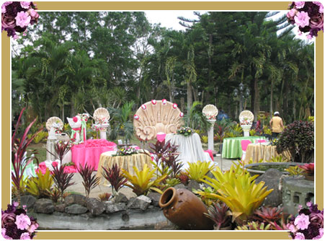 **Hacienda Isabella days hotel garden overlooking taal lake**

**Villa de Oro**